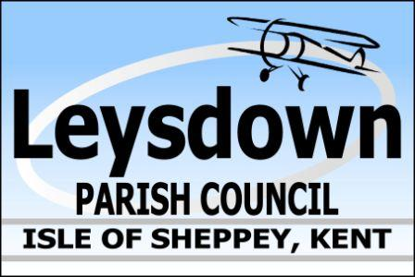

Draft Agenda Ordinary Meeting Leysdown Parish Council
TUESDAY 18th APRIL 2023 at the Village Hall @ 7pm
Wing Road, Leysdown-On-Sea, Kent, ME12 4EA.
leysdownpc@btconnect.com | 01795 511277

To the Councillors of Leysdown Parish Council, you are hereby summoned to attend a meeting of the Leysdown Parish Council convened by the Chair to be held at Leysdown Village Hall, Wing Road, Leysdown-On-Sea, Kent, ME12 4EA.

It is courtesy to inform Councillor that this meeting will be recorded (audio only) and by attending this meeting you give consent to be recorded. The business to be transacted at this meeting is as follows:

23/56 Apologies
23/57 Declaration of Interests
23/58 Approval of Minutes for the meeting held on 21st March 2023
23/59 Matters arising
23/60 Public Session (limited to 15 minutes)
23/61 Correspondence
23/62 Planning:
23/500944/FULL Temporary change of land from agricultural to residential, including creation of a site compound, for use during the relocation and construction of the outbuilding approved under planning permission. Elliotts Barn Harty Ferry Road Leysdown.
23/63 Highways Improvement Plan
23/64 PCSO Update
23/65 CCTV Cameras and request for one installed along Shellness Road.
23/66 Replacement of existing parking bays for a new vehicle access to Vanity Holiday Park.
23/67 Planters and boat update, ref: plants.
23/68 King’s Coronation/payment to be confirmed.
23/69 New rides that have been put on sea front/opp. Toilets
23/70 Membership of KALC and NALC renewal
23/71 Citizen’s Advice Swale requesting a grant
23/72 Councillors Allowances

23/73 Finance Cheques for approval:
BT | £52.81 | Direct Debit
Clerk’s wages inc. tax rebate | £423.60
KSS Air Ambulance | £300.00

Amount in bank £6,683.64

23/74 Second Public Session (limited to 5 minutes)
23/75 Any Other Business
23/76 Date of Next Meeting

23/77 Close of Meeting

Signed:

Lynne King
Parish Clerk

