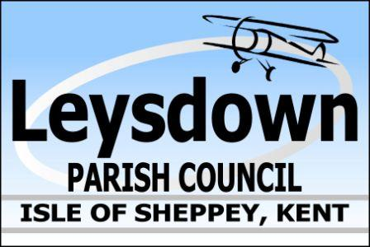

Draft Agenda Extra-Ordinary Meeting Leysdown Parish Council
THURSDAY 29th JUNE 2023 at the Village Hall @ 6pm
Wing Road, Leysdown-On-Sea, Kent, ME12 4EA.
leysdownpc@btconnect.com | 01795 511277

To the Councillors of Leysdown Parish Council, you are hereby summoned to attend a meeting of the Leysdown Parish Council convened by the Chair to be held at Leysdown Village Hall, Wing Road, Leysdown-On-Sea, Kent, ME12 4EA.

It is courtesy to inform Councillor that this meeting will be recorded (audio only) and by attending this meeting you give consent to be recorded. The business to be transacted at this meeting is as follows:

23/107 Apologies
23/108 Declaration of Interests
23/109 Approval of Minutes for the meeting on 30th May 2023
23/110 Matters arising
23/111 Public Session (limited to 15 minutes)
23/112 Correspondence
23/113 Planning:
23/114 CCTV Cameras update with costings.
23/115 Eastchurch Aviation Museum request for funding to purchase historic documents update.
23/116 Shorts Statue Shellness Road update, ref; protective barrier.
23/117 Organisation of Green party/litter pick etc.
23/118 New Boiler for village hall, funding request.
23/119 Swale Link
23/120 Changing dates/days of Parish Meetings
23/121 Sub-Committee Area Report.
23/122 Proposed new printer/office equipment.
23/123 Xmas Party
23/124 Xmas Lights
23/125 Renewal for Councils Insurance
23/126 Leysdown four-year Improvement Plan
23/127 Signing off Accounts
23/128 Finance Cheques for approval:
BT | £51.14 | Direct Debit
Clerk’s wages | £275.00

Balance of NatWest Account as at 12th May 2023 £18,490.28

23/129 Second Public Session (limited to 5 minutes)
23/130 Any Other Business
23/131 Closed Session – Clerk’s Contract/Salary
23/132 Date of Next Meeting
23/133 Close of Meeting

Signed:

Lynne King
Parish Clerk

